IC1-1 (Secondary Data-based Research Preparation)_DMEZA
SUMMER IBM6300 | JUN 14 2026
1. Document Delivery service
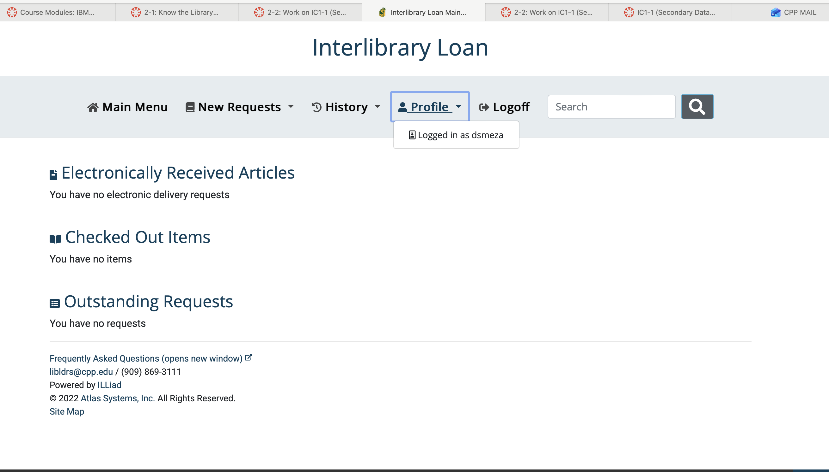
2. VPN (Virtual Private Network)
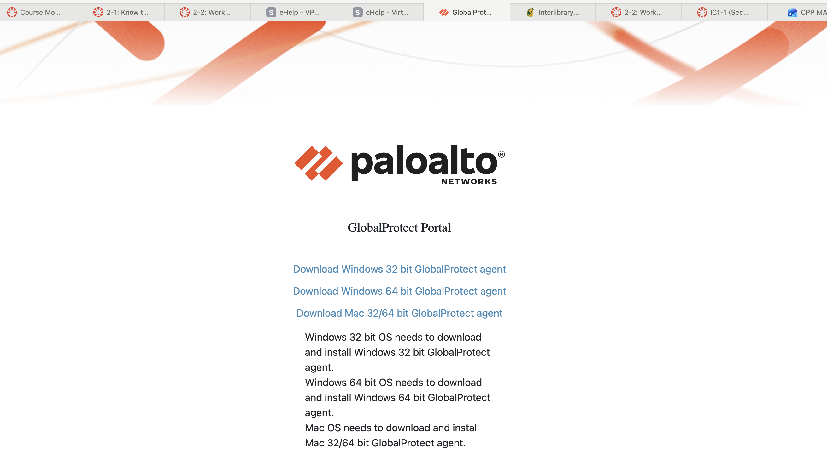
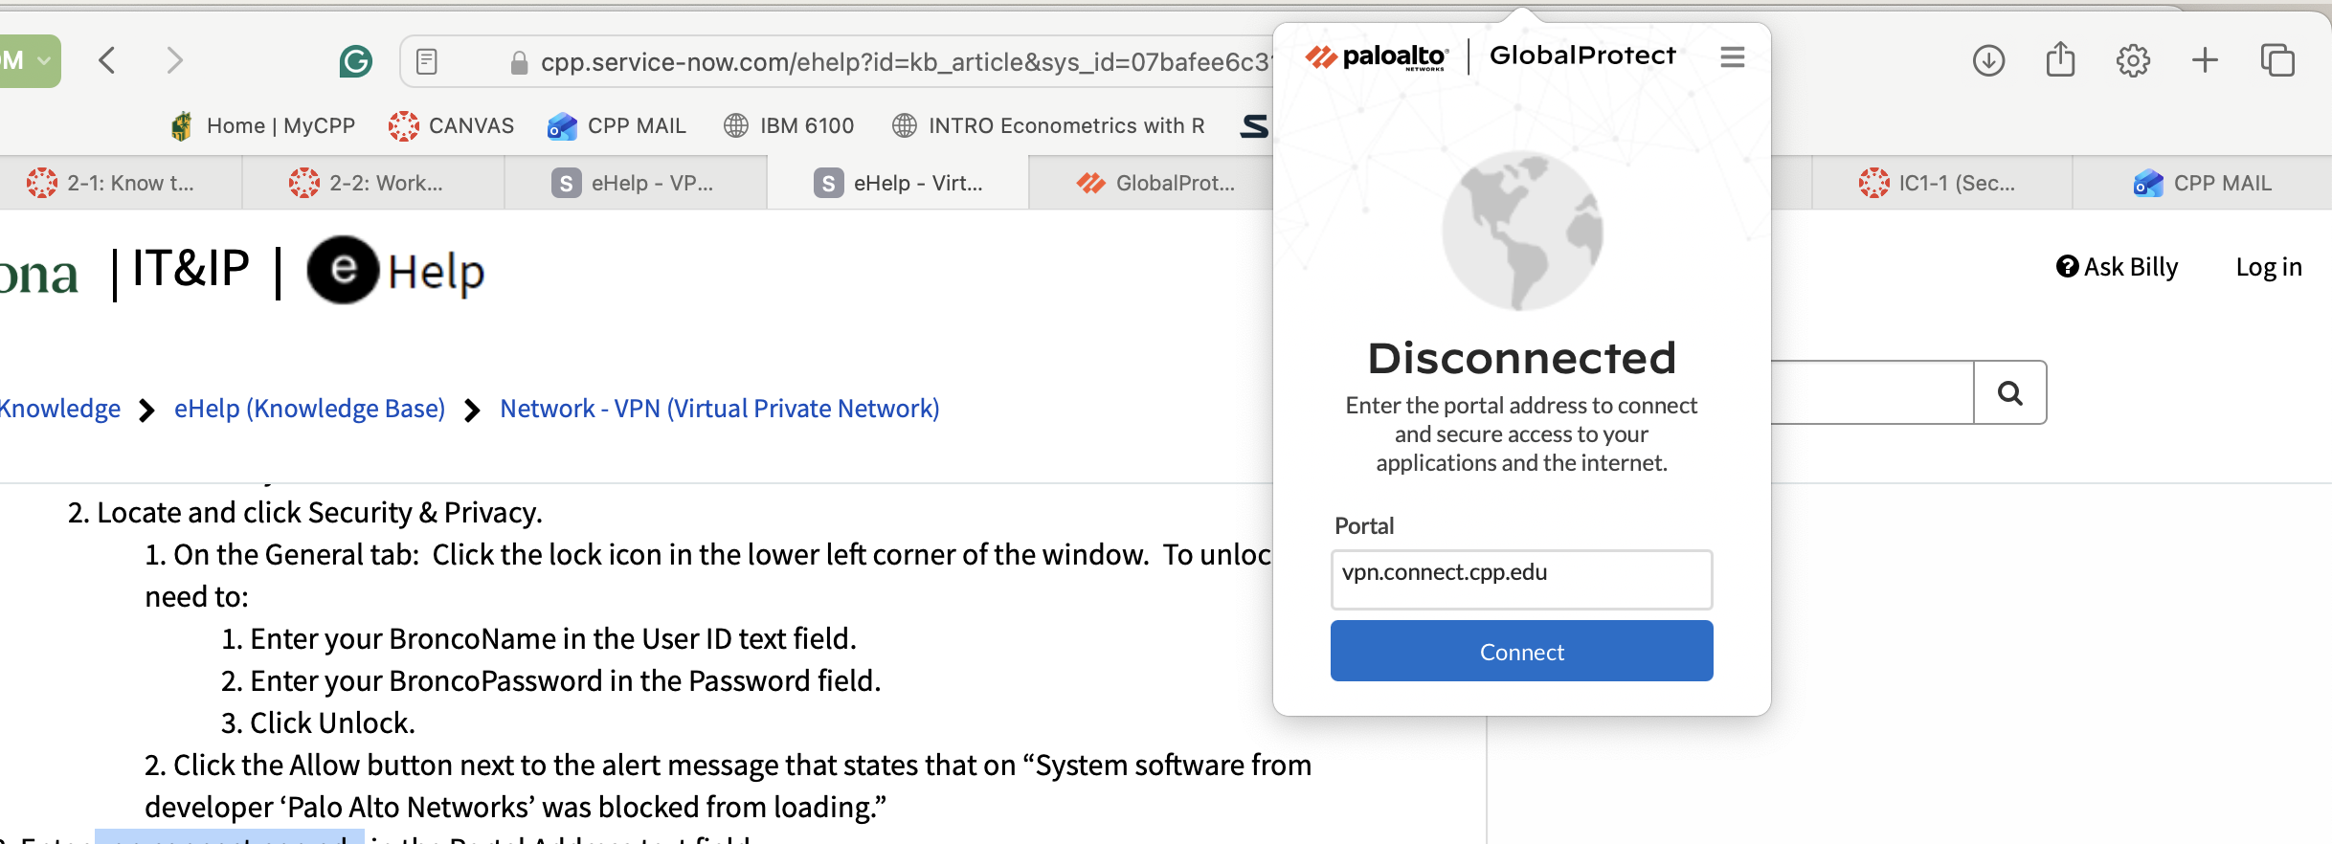

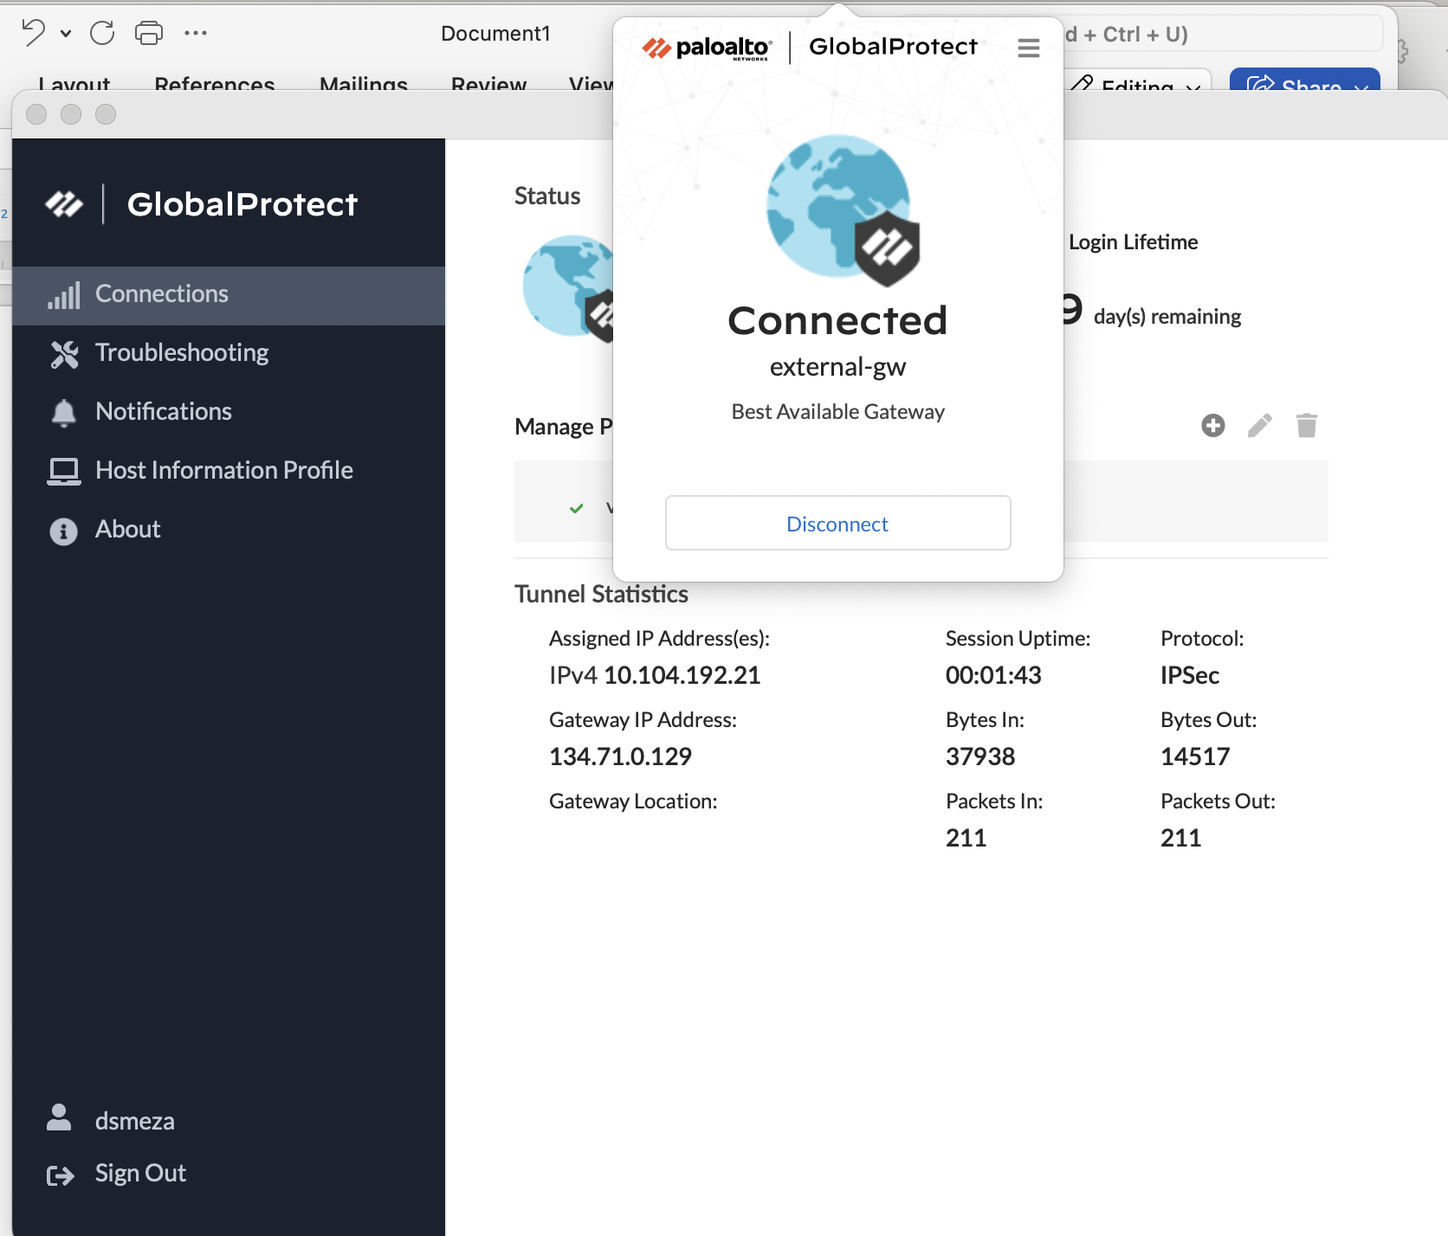

3. Connect Google Scholar to Cal Poly Pomona Library
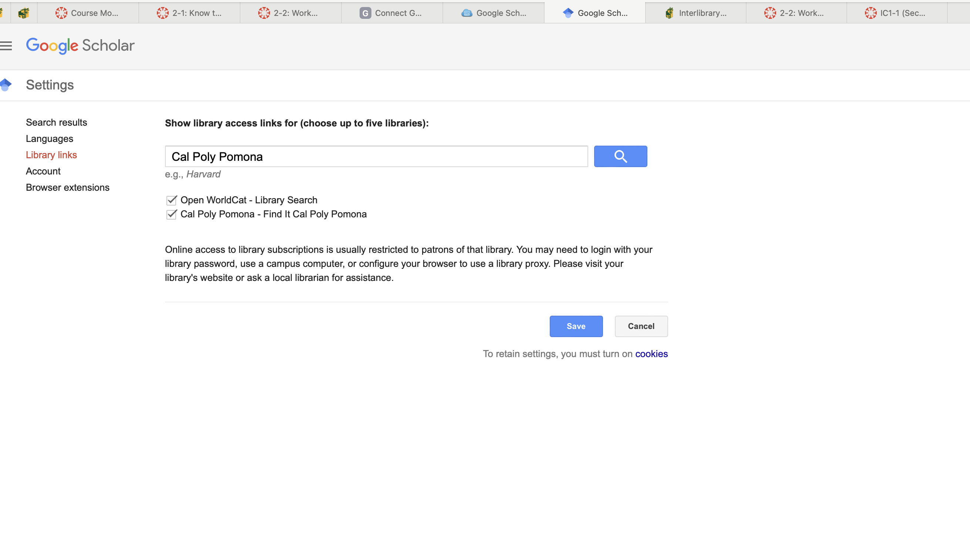
4. Zotero